

**Supporting document 4**

Analysis of control measures and market information – Proposal P1034

Chemical Migration from Packaging into Food

# 1 Control measures

FSANZ determined the range of control measures and uptake by different industry sectors through consultation with a broad range of industry stakeholders[1]. A summary of the outcomes of consultations is presented in Table 1.

FSANZ collated 78 responses through surveys and direct consultations with a broad range of businesses spanning the packaging supply chain. Of the responses received, the majority were from food manufacturers/importers/brand owners (n=51). This response may well be a reflection of FSANZ’s reach in addition to the understandably greater interest and knowledge of food standards and safety issues shown by this industry sector. However, FSANZ also took steps to reach out to other members of the packaging supply chain including small to medium enterprises (SMEs) in different sectors.

Table 1 presents the percentage uptake of regulatory and non-regulatory control measures respectively for raw material suppliers, packaging manufacturers, food manufacturers and food service businesses. All businesses reported that they comply with more than one type of control measure[2]. Overall, the uptake of EU and US regulations was very similar and significantly higher than mention of Australian/New Zealand regulations[3].

All raw material suppliers who responded to the surveys reported they comply with EU and US regulations and 70% comply with Australian/New Zealand regulations. They also comply 100% with Good Manufacturing Practices (GMP) and with a broad range of other non-regulatory measures (50% comply with AS 2070-1999) and stated that they have comprehensive QA/QC management plans in place. It is inferred from responses that these QA/QC plans include a general packaging/food safety component.

Almost all packaging manufacturers/converters reported compliance with EU and US regulations and >60% comply with Australian/New Zealand regulations and other overseas regulations. More than half of the packaging manufacturers responded that they comply with a range of non-regulatory measures and >70% have an audited QA/QC program.

Food manufacturers reported uptake mainly of Australian/New Zealand regulations, whereas only 40−50% refer to EU and US regulations. Only 20 % of food businesses reported uptake of non-regulatory control measures, though 75% had an audited QA/QC program.

Of the food service businesses that responded to the surveys, 60% reported uptake of Australian/New Zealand regulations and only 20% reported uptake of EU/US regulations and non-regulatory control measures. In total, 40% of food service businesses reported that they relied solely on supplier assurance regarding information on CMPF.

## 1.1 Consultation with small-to-medium enterprises

Following initial survey outcomes, it was evident that there were some gaps in FSANZ’s knowledge regarding SMEs[4] in the different industry sectors and their respective approaches to CMPF. The importance of SMEs in the range of business sectors cannot be underestimated in terms of their representation; a point also corroborated by submissions to the November 2014 consultation paper for P1034[5] (see summary of submissions in SD7). FSANZ prepared a survey to target SMEs. It appears there is a broad spectrum of knowledge about CMPF amongst SMEs consulted (n=32) ranging from businesses that have no awareness and no control measures in place, to those with knowledge of the issue and specific control measures in place. The majority of businesses surveyed show some level of awareness of CMPF and have (as a minimum) basic control measures in place (e.g. HACCP). However, uptake of HACCP does not provide assurance of control of CMPF if there is no concomitant food packaging supply chain assurance. The key message from the SME analysis was that there is significant reliance on through-chain stewardship and trusted suppliers.

# 2 Market information

Information on market size and segmentation[6] has been considered in the residual risk model to form an understanding of market share and competitive forces (e.g. import of empty packaging) on the manufacture of different types of packaging materials.

Table 2 provides market share information on the main materials used in the manufacture of packaging in Australia. Data on the number of businesses manufacturing each type of material is reported, together with the number of main manufacturers of each material and their respective market share. This information represents the manufacture of *all* packaging material in Australia; food and beverage packaging accounted for approximately 23.2% of all packaging services in Australia in 2014-15 (revenue = $1.4b)[7].

This information, together with knowledge on the range and uptake of control measures, enables a qualitative estimation of the confidence FSANZ has in industry’s current control of CMPF. A couple of examples of how this information can be interpreted are provided below:

*Example 1*: Corrugated paperboard manufacture is essentially a duopoly in Australia with 95% of this material being supplied by two companies. Both companies comply with a range of domestic and international packaging material regulations in addition to voluntary codes of practice[8] and also have in-house testing and QA/QC schemes.

Therefore, it is anticipated that there is good consistency of application of control measures and we conclude that there would be a relatively high degree of confidence that the residual risk, from most chemicals that could migrate from this packaging material, would be low.

*Example 2:* Some sectors of the packaging manufacturing market consist of smaller companies with a low percentage market share. FSANZ has been unable to verify their awareness of CMPF and use of mitigation measures. It could be argued that there is an increased likelihood of uncertainty in the consistency of application of control measures. This would result in decreased confidence in overall control of CMPF and raise the overall residual risk for a chemical concern.

## 2.1 Imported packaging materials

Imported ‘empty packaging’ was also identified through submissions, and by the Packaging Advisory Group as a potential risk factor or ‘weak link’ in the packaging supply chain as control measures in the source country may be poor or unknown. Market information sources imply that imports of packaging materials are growing due to the increasing competitiveness of the overseas market. This has been confirmed through an analysis of imported packaging data[9] (see Figures 1 and 2). Imports of glass, paper/paperboard, and plastic packaging materials have all increased over the past 3 years[10] (Figure 1). The data shown for each packaging material category includes a range of sub-categories (detailed in Appendix 1) which may be used for food packaging[11].

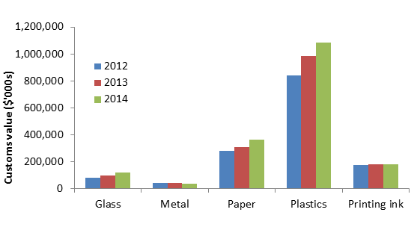

*Figure 1: Imports of major groups of packaging material 2012-20148*

The market for ‘empty packaging’ has apparently shifted in the past few years and it is now more economically viable to import some packaging materials[12]. Some of the increased imports can be attributed to Australia’s major packaging companies, who operate in the global market, and have been increasing their imports of empty packaging. Information from major packaging companies about their control measure practices indicates that the implementation of these measures also extends to imported packaging materials.

Imported packaging may be sourced from a range of countries worldwide and some materials, for example plastics, are sourced from as many as eighty countries. The major exporting countries to Australia are in the Asia-Pacific region and China, the latter dominating the export market for paper/paperboard, plastic and metal packaging materials[13] (Figures 2 and 3).

**A**

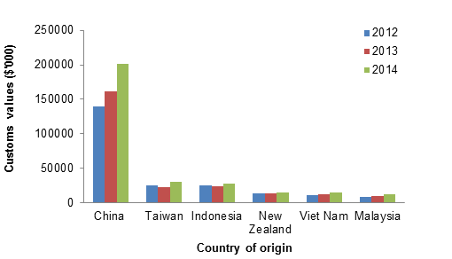

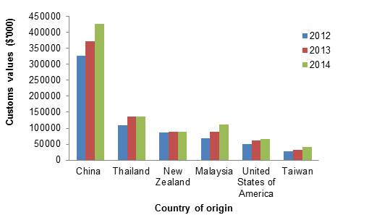

**B**

*Figure 2: Major exporters of packaging materials to Australia 2012 – 2014: (A) paper/paperboard (B) plastics8.*

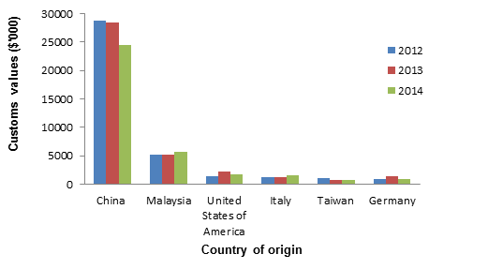

**A**

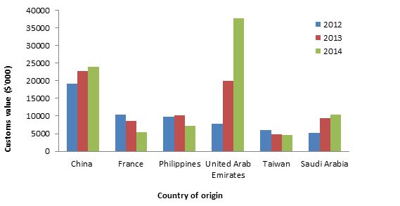

**C**

**B**

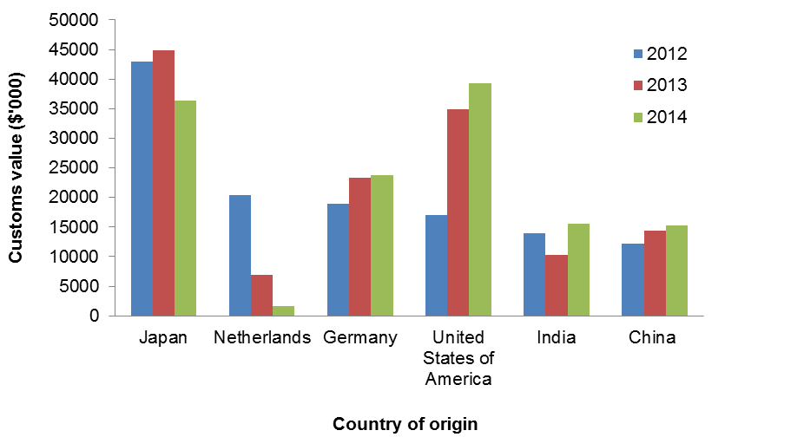

*Figure 3: Major exporters of packaging materials to Australia 2012 – 2014: (A) metal (B) glass (C) printing inks8*

## 2.2 Market outlook

Over the past few years there has been a shift in the popularity of the types of packaging materials used. This is related not only to the functions of packaging i.e. containment, protection, convenience and communication (Robertson 2013), but also to increased demand for ‘lightweighting’ of packaging materials. Environmental concerns and the economics of carbon tax, transport and raw material supply have influenced the shift to using lighter weight plastic composite packaging (such as flexible plastic pouches) for a large array of food products[14].

**Table 1: Summary of responses (n=78) from industry on self-reported uptake of regulatory and non-regulatory control measures relating to chemical migration from packaging into food**



**Key:**

1 Other international regulations include China’s GB 9685-2008 Hygienic Standard; Japan’s Food Sanitation Law; Swiss and German Ordinance requirements for printing inks

2 Examples of industry standards, including ISO14001; ISO9001: 2000 GB / T19001-2000 standard; ISO 22000; or SQF22000

3 Hazard Analysis and Critical Control Points

4 Good Manufacturing Practice

5 Australian Standards AS 2070-1999 -: Plastics materials for food contact use

6 The Confederation of European Paper Industries guideline

7 The European Printing Ink Association guideline

8 Examples of Quality Assurance/Control systems may include: a) Specifications; b) Contracts: c) Packaging Requirements documentation; d) Electronic Fingerprinting testing (in house and at supplier); and e) supplier quarterly reviews.

**Table 2: Market share data for packaging materials**

| **Packaging material** | **% market share[15]** | **Number of businesses** | **Number of main manufacturers (% market share)** | **Reference** |
| --- | --- | --- | --- | --- |
| (% overall share of the Economy) |
| **Paper/paperboard** | 36 |  |  |  |
| Pulp, paper and paperboard  (0.02%) |  | 187 | 3 (83.6%) | Anning, J. (2014a) |
|  |
| Paperboard container (0.01%) |  | 56 | 4 (73.4%) | Anning, J. (2014b) |
|  |
| Corrugated paperboard (0.05%) |  | 68 | 2 (95%) | Ivanov, A. (2013) |
|  |
| Paper bag |  | 184 | 4 (50%) | Gargano, S. ( 2014) |
|  |
| **Plastics** | 30 |  |  |  |
| Plastic blow-moulded (0.03%) |  | 137 | 3 (80%) | Little, S. (2014a) |
|  |
| Plastic injection moulded  (0.04%) |  | 1044 | 4 (20%) | Lin, R. (2013) |
|  |
| Plastic bag and film  (0.05%) |  | 281 | 2 (33%) | Little, S. (2014b) |
|  |
| **Metal** | 20 |  |  |  |
| Sheet metal  (0.06%) |  | 1400 | 3 (<10%) | Kelly, A. (2014a) |
|  |
| Metal drum, can and bin |  | 200 | 4 (77%) | Kelly, A. (2013) |
|  |
| **Glass**  (0.07%) | 10 | 755 | 2 (42%) | Kelly, A. (2014b) |
|  |
| **[16]Adhesives**  (0.02%) | <4% | 50 | 3 (31%) | Richardson, A. (2014a) |
|  |
| **Printing inks** | <4% | 5155 | 2 (11.2%) | Little, S. (2014c) |
| **Raw material manufacture** |  |  |  |  |
| Synthetic resin and synthetic rubber | <4% | 55 | 2 (25.4%) | Richardson, A. (2014b) |
|  |  |

**References**

Anning, J. (2014a) Pulp, Paper and Paperboard Manufacturing in Australia. IBISWorld Industry Report C1510.

Anning, J. (2014b) Paperboard Container Manufacturing in Australia. IBISWorld Industry Report C1521a.

Gargano, S. (2014) Paper Bag and Other Paper Product Manufacturing in Australia. IBIS World Industry Report C1528.

Ivanov, A. (2013) Corrugated Paperboard Container Manufacturing in Australia

IBISWorld Industry Report C1521b.

Kelly, A. (2013) Metal Drum, Can and Bin Manufacturing in Australia. IBISWorld Industry Report C2239.

Kelly, A. (2014a) Sheet Metal Product Manufacturing in Australia. IBISWorld Industry Report C2240.

Kelly, A. (2014b) Glass and Glass Product Manufacturing in Australia. IBISWorld Industry Report C2010.

Lin, R. (2013) Plastic Injection Moulded Product Manufacturing in Australia. IBISWorld Industry Report C1912b.

Little, S. (2014a) Plastic Blow Moulded Product Manufacturing in Australia. IBISWorld Industry Report C1912a.

Little, S. (2014b) Plastic Bag and Film Manufacturing in Australia. IBIS World Industry Report C1911.

Little, S. (2014c). Printing in Australia. IBISWorld Industry Report C1611.

Richardson, A. (2014a). Adhesive Manufacturing in Australia. IBISWorld Industry Report C1915.

Richardson, A. (2014b). Synthetic Resin and Synthetic Rubber Manufacturing in Australia. IBISWorld Industry Report C1821.

Robertson G.L. (2013) Food Packaging: Principles and Practice, 3rd edn. Boca Raton, FL: CRC Press.

**Appendix 1: Sub-categories of packaging materials (Source: ABS, 2015)**

|  |  |
| --- | --- |
| **Packaging material** | |
| **Broad category** | **Sub-categories** |
| Paper/paperboard | * Cartons, boxes and cases of corrugated paper or paperboard * Folding cartons, boxes and cases of non-corrugated paper or paperboard * Sacks and bags, having a base of a width of 40 cm or more, of paper, paperboard, cellulose wadding or webs of cellulose fibres * Sacks and bags (incl. cones) of paper, paperboard, cellulose wadding or webs of cellulose fibres * Packing containers of paper, paperboard, cellulose wadding or webs of cellulose fibres * Trays, dishes, plates, cups and the like, of paper or paperboard of bamboo * Trays, dishes, plates, cups and the like, of paper or paperboard (excl. bamboo) |
| Plastic | * Flexible food grade film >= 6% of plasticisers * Flexible food grade film < 6% of plasticisers * Plates, sheets, film, foil and strip, of non-cellular plastics * Boxes, cases, crates and similar articles of polymers of styrene or of vinyl chloride * Boxes, cases, crates and similar articles of polymers of ethylene or of propylene * Other boxes, cases, crates and similar articles of plastics * Shopping bags of low density polyethylene * Shopping bags of polyethylene * Shopping bags of polymers of ethylene * Sacks and bags of low density polyethylene * Sacks and bags of polyethylene * Sacks and bags of polymers of ethylene * Plastic sacks and bags * Carboys, bottles, flasks of styrene or of polymers of vinyl chloride * Carboys, bottles, flasks and similar articles of polymers of ethylene or of polymers of propylene * Plastic carboys, bottles, flasks * Stoppers, lids, caps and other closures, of polymers of styrene or of polymers of vinyl chloride * Stoppers, lids, caps and other closures, of polymers of ethylene or of polymers of propylene * Plastic stoppers, lids, caps and other closures * Other articles for the conveyance or packing of goods, of polymers of ethylene or of propylene * Collapsible plastic tubes for the conveyance or packing of goods * other plastic articles for the conveyance or packing of goods |
| Glass | wine bottles; beer bottles; other bottles; jars; containers and closures. |
| Metal | cans (<50L); iron or steel tanks, casks, drums, cans. |

1. Consultations were undertaken through advisory group meetings, phone interviews, surveys and responses/submissions to the consultation paper <http://www.foodstandards.gov.au/code/proposals/Pages/P1034ChemicalMigrationfromPackagingintoFood.aspx>
2. Note, not all of the control measures would be relevant for each industry sector in the packaging supply chain.
3. References to uptake of regulatory control measures was with regard to CMPF only
4. SMEs are considered businesses with 1-199 staff (small businesses according to the Australian Bureau of Statistics (ABS)) have 1-19 staff and medium-sized businesses have 20–199 staff. Many survey responses were from very small businesses with <5 staff.
5. <http://www.foodstandards.gov.au/code/proposals/Pages/P1034ChemicalMigrationfromPackagingintoFood.aspx>
6. from IBIS World Business Reports
7. IBISWorld (August 2014) Industry Report N7320 Packaging Services in Australia.
8. Information on packaging material regulatory and non-regulatory requirements in Australia/New Zealand and overseas are available in supporting documents ([SD1](http://www.foodstandards.gov.au/code/proposals/Documents/P1034-Packaging-CFS-SD1.pdf), [SD2](http://www.foodstandards.gov.au/code/proposals/Documents/P1034-Packaging-CFS-SD2.pdf) and [SD7](http://www.foodstandards.gov.au/code/proposals/Documents/P1034-Packaging-CFS-SD7.pdf) respectively) to the [Consultation Paper](http://www.foodstandards.gov.au/code/proposals/Documents/P1034-Packaging-Consult-CFS.pdf): <http://www.foodstandards.gov.au/code/proposals/Pages/P1034ChemicalMigrationfromPackagingintoFood.aspx>
9. Source: Australian Bureau of Statistics (ABS)
10. Values provided are deflated customs values for the sum of sub-categories of materials that may be used for food packaging.
11. FSANZ does not have information on the final use of the packaging materials.
12. Euromonitor International (January 2014) Packaging Industry in Australia
13. Data excludes state administered regions of China and Taiwan.
14. Euromonitor International (January 2014) Packaging Industry in Australia
15. Packaging Council of Australia (2005) <http://pca.org.au/application/files/4314/3795/7882/00499.pdf> *accessed on 17.02.2016*
16.